Progress Report #1

These progress reports will be INDIVIDUAL assignments. That means you will be setting goals that you intend to accomplish this week. Be specific; set goals that can be completed in one or two weeks. In future reports, you will need to report on the success, change, or continuation of each goal.

**Goal #1: Build physical box with separator and door(s).**

**Goal #2: Finish circuit testing.**

**Goal #3: Start LCD code on MCU.**

Each report must be accompanied by an updated schedule in the form of a Gantt chart. You will need to submit the previous week’s chart in addition to the current one, so that we can monitor your progress. The Gantt chart is for your entire project, so it will reflect your entire team’s progress. There is no need to create a new chart that reflects your individual progress unless you are the only member of your team.

For this week, use the chart from your Design Review presentation. Save the chart as a pdf and attach it below.

*Gantt chart has not changed from the original yet.

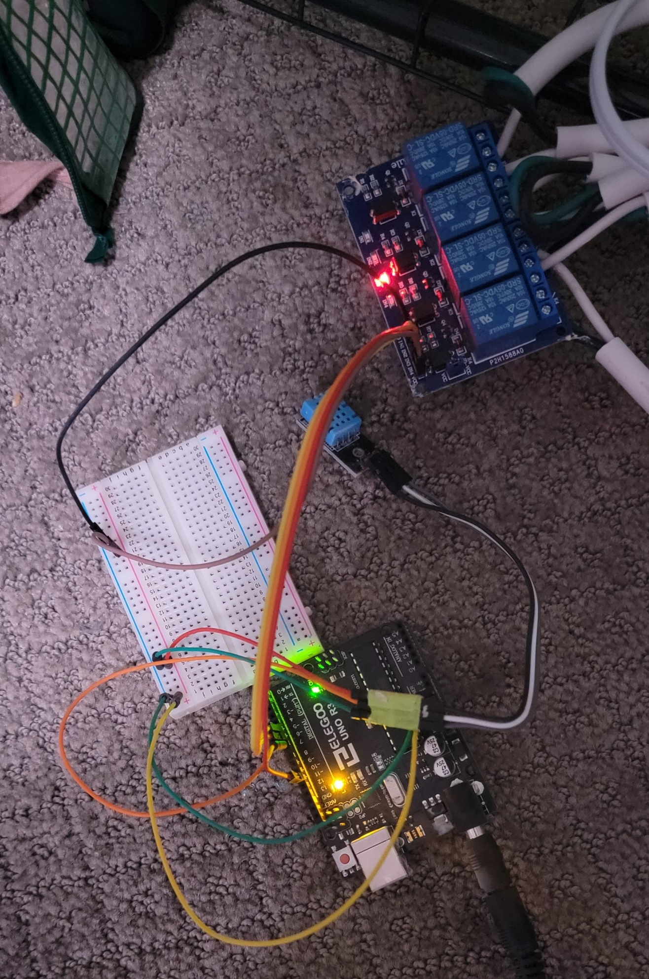

The above picture is of some of the circuitry controlling the individual components via 5V relay and a sensor. An Arduino board has been programmed to test the circuits for functionality before moving on. Other parts of the circuit have been built (fan and light controls) but disassembled after verifying they worked.